Compass Run
A virtual reality orienteering experience in which the player navigates a natural environment using a map and compass to locate a sequence of checkpoints.

Team members: Farcas Alexandru Eduard, Cantea Elina Nicoleta, Gutuleac Alexandru, Mironescu Bianca Ioana

Description
- Orienteering is a sport that combines navigation, map reading, spatial awareness and route planning. Practising the sport normally requires access to an outdoor environment, a prepared course and multiple checkpoints placed in advance. The purpose of this application is to reproduce the essential mechanics of orienteering in virtual reality, allowing users to practise navigation and spatial reasoning in a controlled and accessible environment.
- The player will be placed inside a virtual outdoor environment containing multiple checkpoints. At the beginning of the course, the player receives a map and a virtual compass. Using these tools together with visible landmarks in the environment, the player must identify the correct route and reach each checkpoint in the required order.
The application will track the player's progress, validate visited checkpoints and measure the total completion time. The player will be free to choose the route between checkpoints instead of following a predefined path.
- Unlike general VR exploration or hiking applications, VR Orienteering focuses specifically on the mechanics of competitive orienteering. The experience requires the player to interpret a map, use a compass, recognize environmental landmarks, choose efficient routes and find checkpoints in the correct order.

Similar products & Relevant Links

Name: Orienteering VR
Description: The player navigates through a forest environment, reads the map, utilizes a compass, and searches for checkpoints. The game features a beginner tutorial, a night navigation mode, and the capability to generate course maps based on real-world orienteering maps.
Url: https://orienteeringvr.cc/
Relevant Features
- Map and compass-based navigation.
- Checkpoint validation and course completion.
- Time-based performance objectives.
- Natural environments and terrain exploration.
- Tutorial for learning the basic mechanics.

Name: Orientr
Url: https://www.ventrout.com/
Description: Orientr is a VR orienteering training simulator designed to help users practise map reading, terrain interpretation, route choice and reorientation. It emphasizes independent navigation instead of providing continuous directional guidance.
Relevant Features
- Virtual orienteering maps and compass navigation.
- Independent route selection.
- Terrain interpretation and spatial awareness.
- Repeated practice on different courses.
- Course completion and performance review.

Name: Virtual-O
Description: Virtual-O is a PC orienteering game that recreates the navigation challenges of the sport. Players use a map and compass to explore an unfamiliar environment and find their way through the course.
Url: https://store.steampowered.com/app/529020/VirtualO/
Relevant Features
- Map-based navigation.
- Compass use and orientation.
- Exploration and route-finding.
- Sports simulation mechanics.

Main Features

Core Feature
- The player must navigate through a virtual natural environment and locate a predefined sequence of checkpoints using only a course map, a compass and environmental landmarks.

- The player is not given a fixed route between checkpoints and must choose how to travel from one checkpoint to the next.

Supporting Features
- Virtual map that can be picked up and inspected by the player.
- Functional virtual compass that indicates the direction of North.
- Multiple checkpoints placed throughout the environment.
- Checkpoints must be reached in a predefined order.
- Automatic checkpoint validation when the player reaches the correct checkpoint.
- Visual and/or audio feedback when a checkpoint is successfully validated.
- Timer that starts when the course begins and stops when the course is completed.
- Results screen displaying the final completion time.
- Outdoor terrain containing trees, paths, rocks, hills and other landmarks.
- Free route choice between checkpoints.
- Start and finish areas.
- VR controller interaction for the map and compass.
- Tutorial introducing movement, map usage, compass usage, and checkpoint validation.

User Journey Diagram
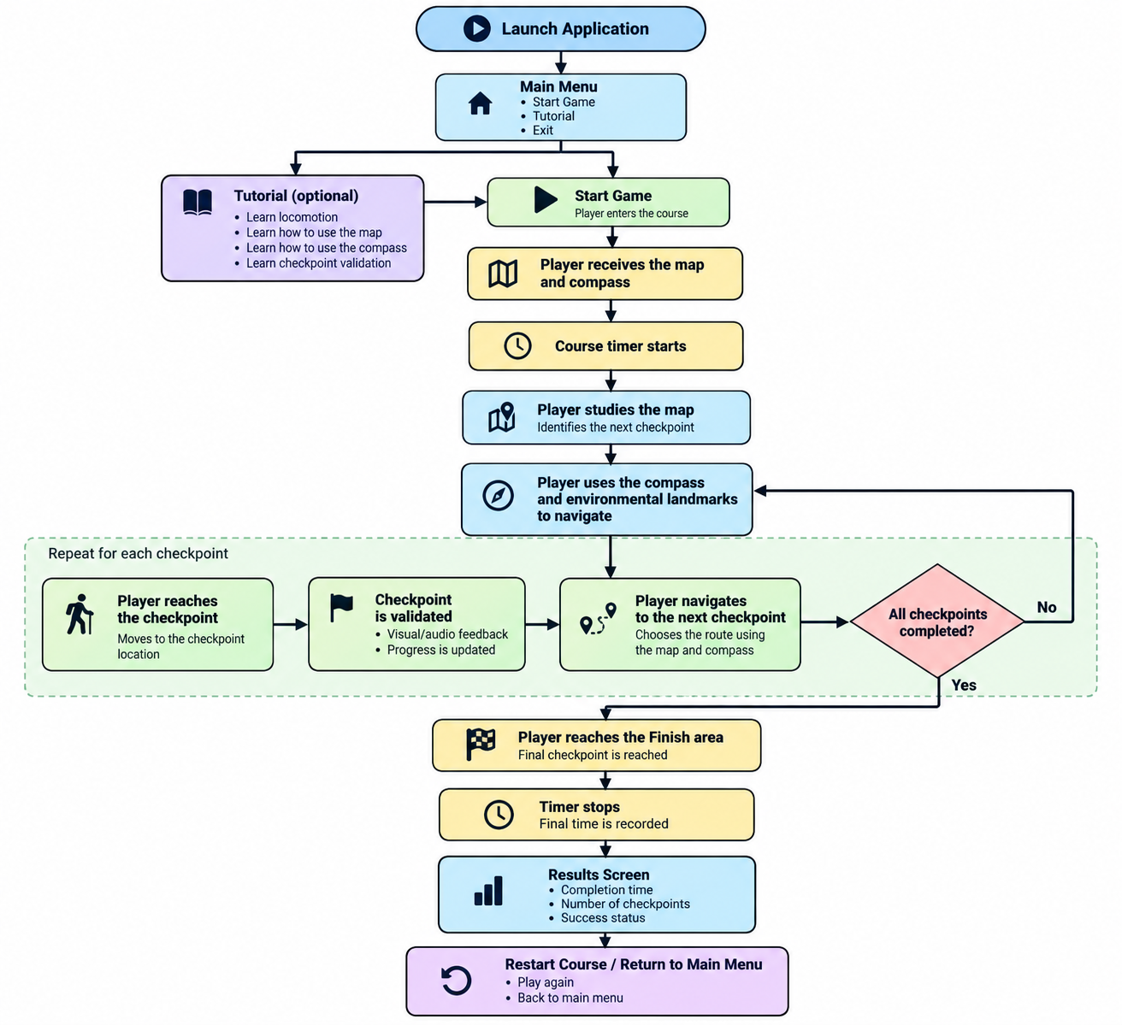

Moodboard

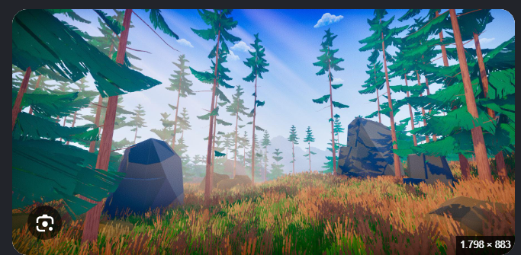


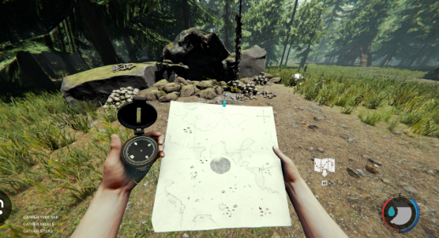



Technologies, Libraries & Assets

1. Unity 6
Primary engine used to build the virtual reality application.

2. OpenXR
Provides a cross-platform XR runtime interface for VR hardware.

3. XR Interaction Toolkit
Handles XR input, object grabbing, interactions, and locomotion mechanics.

4. XR Device Simulator
Allows desktop testing of XR interactions without requiring a connected headset.

5. Blender
Used to create and modify custom 3D assets.

6. TextMeshPro
Used to render high-quality text throughout the user interface.

7. Unity Terrain System
Used to create the outdoor terrain, elevation, and natural landscape.

8. Unity Asset Store / External 3D Assets
Provides environmental props, trees, foliage, rocks, and structural landmarks.

